By Registered Post with Ack. Due

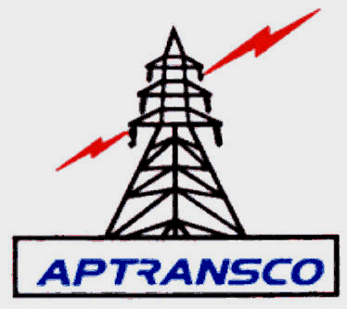
ENERGY SAVED IS ENERGY PRODUCED

From, To
Chief Engineer, M/s A.Venkat Rao,
Metro Zone, H.No.1,Kalwacharla,
Erragadda, kamanpur,
Hyderabad – 500 045. Karimnagar ,Hyderabad.

Lr.No.CE/METRO ZONE/Hyd/ADE (O&M)/AE(O&M)/F: /D.No. 1815 /13, Date: 02 -12-13.
Sir,
Sub: - Metro Zone – Hyderabad – Arrangement of watering to earth pits at 220 KV
Chandrayanagutta - letter of Intent – Issued- Regarding.

Ref: - 1) Tender Notice No. CE/MZ/O&M/ew-07/2013-14.
*****
The rates offered by you, against this office tender notice cited at reference (1) for taking
up the work of “Arrangement of watering to earth pits at 220 KV Chandrayanagutta” is hereby accepted for a total value of Rs.9,54,495.00 (Rupees Nine Lakhs Fifty Four Thousand Four Hundred and Ninety Five Only) ( @ 6.39% less on ECV Value ) as detailed in the schedule (which includes S.T @12.36% on 40% & Labour cess@1% of sub total value) enclosed.

The EMD paid by you vide D.D.No: 099473, Date: 05-11-2013 for Rs.20,400/- is adjusted towards partial security deposit. Further, you are requested to pay balance Security deposit for an amount of Rs. 27,325.00 (Rupees Twenty Seven Thousand Three Hundred and Twenty Five Only) by way of Demand Draft favoring “Superintending Engineer/O&M/400 KV Mamidipally” and payable at Hyderabad before commencement of work. The period of contract is 2 (two) months from date of handing over of site.

You are requested to contact the Superintending Engineer/Civil/O&M/Metro along with Demand Drafts towards balance security deposit and enter into agreement within 15 days from date of receipt of this letter, failing which the LOI issued will be treated as cancelled and further necessary action will be taken.

Yours faithfully,

Encl: Schedule. Sd/-
CHIEF ENGINEER (FAC)
METRO ZONE/HYDERABAD

Copy to,
The Superintending Engineer/ Civil/O&M/Metro *
The Superintending Engineer / O&M/400 KV Mamidipally.
The Executive Engineer /Civil/O&M/Metro.
The Divisional Engineer/TL&SS/ Chandrayanagutta.
The Accounts Officer O/o Superintending Engineer/ O&M/400 KV Mamidipally .
* It is requested to enter into agreement with the firm duly following APTRANSCO procedure with
in 15 days from the date of receipt of this letter by the contractor. Copy of specification is mailed
to ERP mail Id.

